**Local Web Product QR generator**

This web application is meant to be hosted locally and accessible via WiFi in the first line of the chain (factories, production places etc), and thus is not hosted online.

**Requirements:**

* An running XAMPP server (Apache/PhpMyAdmin) and is visible to the network.
* A web browser
* Internet connection , and is allowed to access NXT peer (<http://174.140.168.136:6876/>)
* SQL database created

**How to get the app running:**

1. Have Xampp installed on a computer
2. Download files from <https://github.com/xLesterGG/generateQR>
3. Rename the folder to generate and move them to YourDriveLetter:\xampp\htdocs, the final path should look something like C:\xampp\htdocs\generate.  
     
   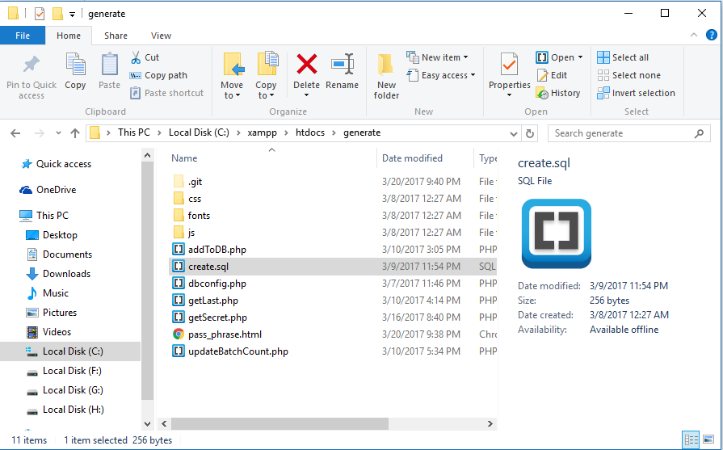
4. Launch Apache and MySQL from Xampp control panel.

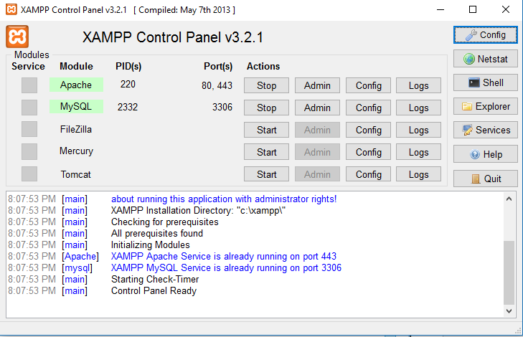

1. Navigate to localhost/phpmyadmin and click on the SQL tab

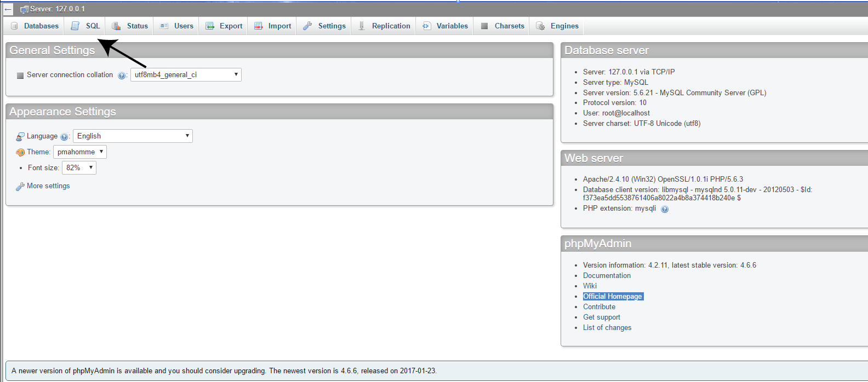

1. Copy the content from C:\xampp\htdocs\generate\create.sql and paste it inside the text field. Then press go to create the database.

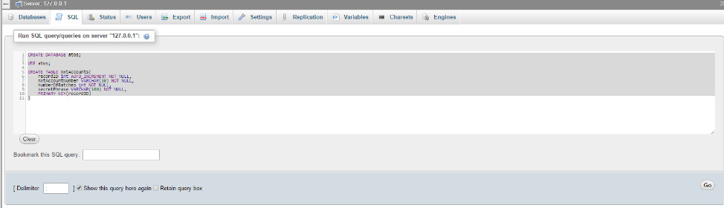

1. Navigate to <http://localhost/generate/pass_phrase.html>. The web application should be loaded and everything should work well.
2. Should the mySQL database have a non-default username and password, change them in dbconfig.php.

**Open source libraries used:**

* Javascypt - <https://www.fourmilab.ch/javascrypt/pass_phrase.html>
* QR generator - <https://davidshimjs.github.io/qrcodejs/>

**External API used:**

* NXT Api

**Files to take note of:**

* pass_phrase.html – The view page
* js/controller.js – Contains all the logic for the web app, and also the functions done in the background.

**Use Case:**

1. A worker has 60 apples, and divide them into packs to 6 ending up with 10 packs.
2. The worker proceeds to generating the QR for this batch of 60 apples using the ***generate web application*** (FoodChain- Product QR Generator).
   * Product QR will be used by the ConsumerApp to filter for that particular batch (via batchID)